**Mr. Vickers’ Class Expectation Reminders Name ________________**

Class rules are always reviewed at the start of each semester. As homework, students are to review the rules/expectations with a parent. A copy of the behavior reminder is on the back of this handout. The behavior reminder will be sent home if a student is having difficulties in class. There is much to cover this semester and taking time to review school/home expectations will result in a productive Spring!

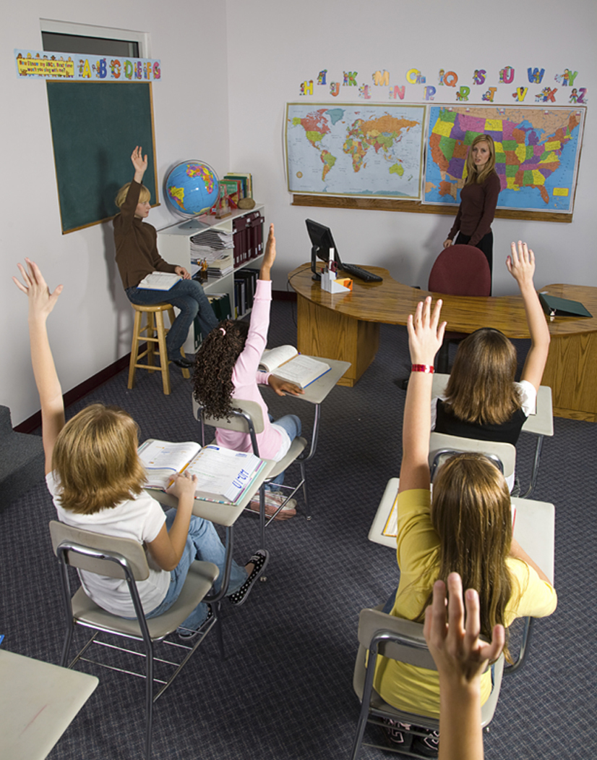

**Entering The Classroom:**

1. Go to assigned desk and take out Study Habits

2. Copy Study Habits

3. Take out supplies and homework

4. Begin warm-up or listen for instructions



***Do Not***:

1. Enter Class Loudly

2. Enter class to socialize first, learn second

3. Gather at the door before the bell rings

**Demonstrate Respect by:**



1. Accepting “No” as an answer

2. Following teacher directions

3. Complying with redirects

**Give Me Five (Interactive Listening Plan):**

1. Eyes on Teacher



2. Mouths Closed

3. Ears Listening

4. Hands on Desk

5. Feet on Floor

**Team/Class Rules:**

1. Be prepared, on time, and on task.

2. Show respect for everyone.

3. Follow directions the first time.

4. Keep hands, feet, and objects to yourself.

5. Have no gum, unauthorized food, or drinks in class.



**Classroom Behavior Update**

______________________________ is getting this notice to inform his/her parents that the following action(s)/item(s) occurred today in class:

* Didn’t turn in homework and received a zero.
* Didn’t use class time wisely and is behind in class-work.
* Talked excessively and continued to do so after being redirected by the teacher.
* Was disrespectful to the teacher.
* Other: __________________________________________________________

__________________________________________________________

Student description of the infraction:

________________________________________________________________

________________________________________________________________

________________________________________________________________

________________________________________________________________

________________________________________________________________

**Parents**: Please talk with your student and reinforce proper home/school expectations. A conference or even an email is not necessary but I wanted you to be aware of any class concerns that involve your student. Obviously, continued behavior concerns may/will result in an office referral. However, I suspect that my concern(s) will quickly disappear after you and your student discuss the concern(s) together. This notice should be returned tomorrow.

Thanks in Advance,

RVickers

________________________ ___________ ________________________

Student Acknowledgement Date Parent Acknowledgement

**Handout Directions:**

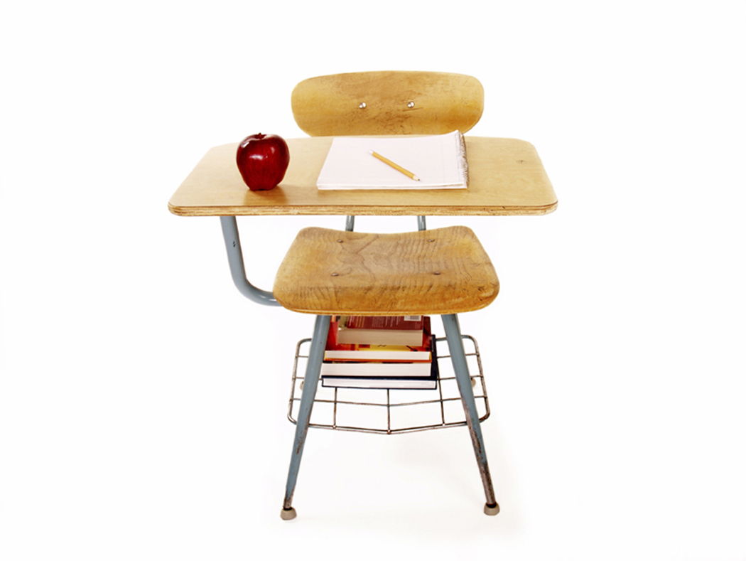

1. Read and discuss both sides of this page with your child.

2. Sign below to verify that you have reviewed the handout.

3. Students are to return the handout to Mr. Vickers.

Thanks, Mr. Vickers

________________________ _________ ________________________

Student Acknowledgement Date Parent Acknowledgement